Laura Rojas Solís

Lvrs0505@gmai.com

07/07/2021

Version 01.03

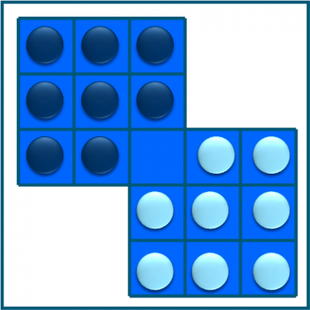

USER MANUAL

CHANGE OF CHIPS

**CONTROL SHEET**

|  |  |  |
| --- | --- | --- |
| **item** | **State %** | **remarks** |
| **Sections of the game** |  |  |
| ✓ Home screen | Complete (100%) |  |
| ✓ Game solution | Incomplete |  |
| ✓ Archives | Complete (100%) |  |
| ✓ Reports | Incomplete | reports are missing. |

# **INDEX**

**INDEX** 2

**1** **SYSTEM DESCRIPTION** 3

**1.1** **Object:** 3

**1.2** **Scope:** 3

**1.3** **Funcionality**: 3

**2** **SYSTEM DESCRIPTION** 4

**1.1** **Logical Model** 4

**1.2** **Navegation** 5

**3** **SYSTEM MAP** 8

**ANEX** 9

# **SYSTEM DESCRIPTION**

## **Object:**

Put in a simple context the use of the CHANGE OF CHIPS program.

## **Scope:**

Through images and explanatory notes facilitate the user the execution of the program CHANGE

OF CHIPS

## **Funcionality**:

The file has 16 pieces that must be placed in an inverted color position through a single space; with as few moves as possible, for which the tiles can be moved to an adjacent square or jump on a tile of the opposite color to an empty square, vertically and horizontally, but not diagonally.

# **SYSTEM DESCRIPTION**

## **Logical Model**

It has 3 windows and one more where statistics between players are graphically represented.

*The initial screen:*

On this screen you will find the information of the editor, the current date and time, in addition to the users already registered.

*The user registration screen:*

It asks the user for the name, and the user name with which they want to be identified by the system.

*The game screen:*

Not because it is the final screen is the least important, since it is where the main functions of the system are performed. It is the screen on which the user seeks to solve the ordering of the tabs.

It also has counters for the moves made, as well as the current date and time, a button to restart the game for when the possibility of winning is closed.

*Query screen:*

The following information is displayed on a screen following the initial one:

1. Pie chart with the ratio of number of resolved vs. number of game restarts.

2. Bar chart with the top 3 of the people who have solved the game the most times.

3. Bar chart with the top 3 of the games solved with the least amount of adjacent moves.

## **Navegation**

Welcome Windows

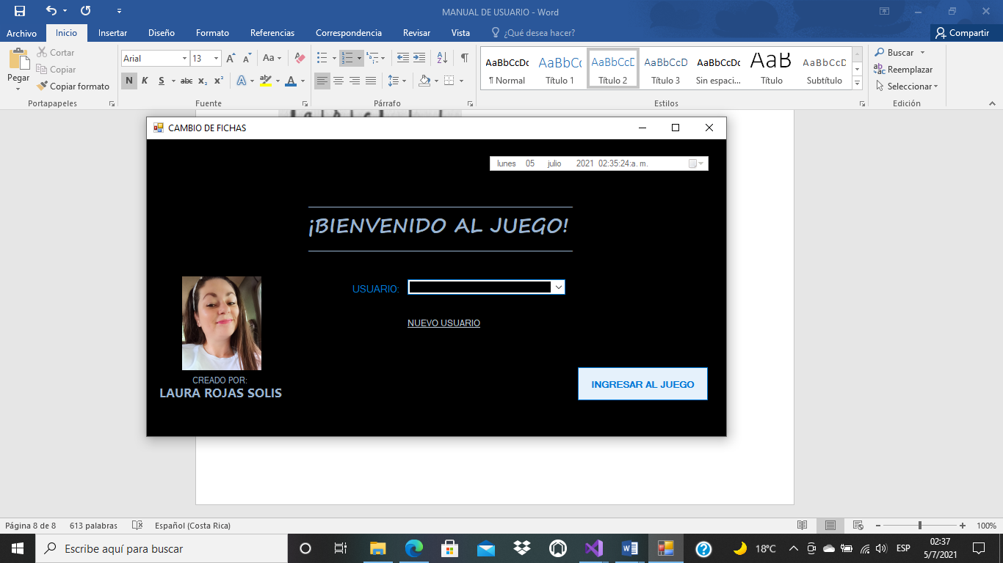

Do you can choose your user, if you are not register, you can do it, select in NUEVO USUARIO

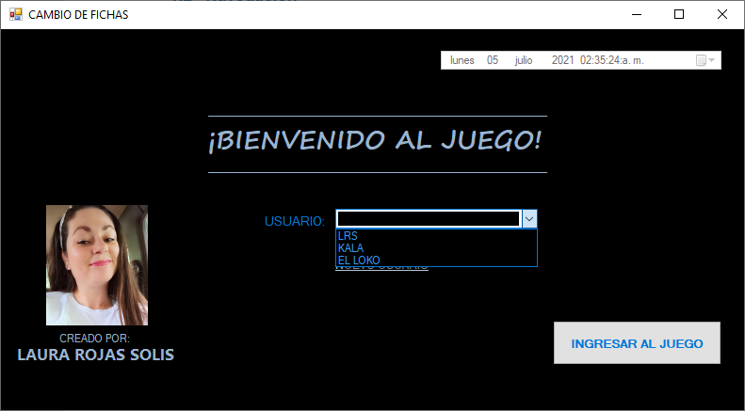

If you select NUEVO USUARIO, this open a new window, where you need write your name and choose a user name, this is unique name, repeat it is not posible.

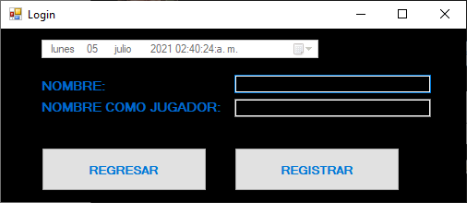

When you write your user and your name, then push REGISTRAR buttom. If your information is right, then appear this window.

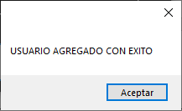

Select ACEPTAR, and then return the principal window.



Do you can press INGRESAR AL JUEGO buttom, but do you need select one user at least; else this Windows appear you inmediatly:

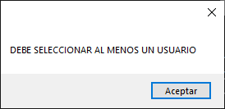

For example, I select my user “Dino”, later I press the buttom to Access at play window.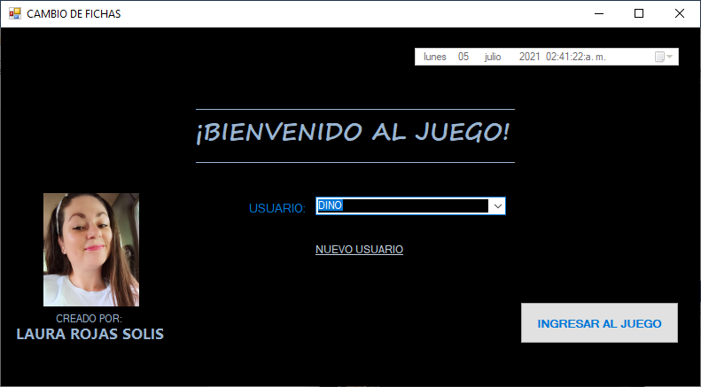

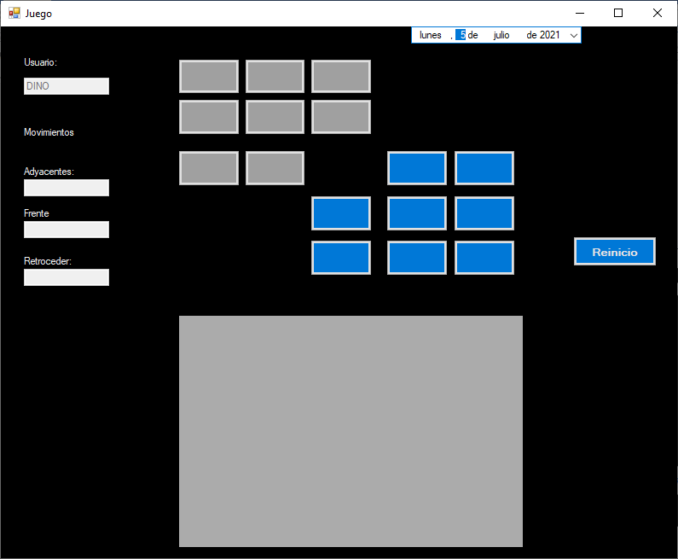

# **SYSTEM MAP**

This are the Windows of de system:

Principal Window:





Register user Window:

Play time Window



# **ANEX**

Hoffman's solution of 52 moves is (each number indicates the box in which the moving tile is).

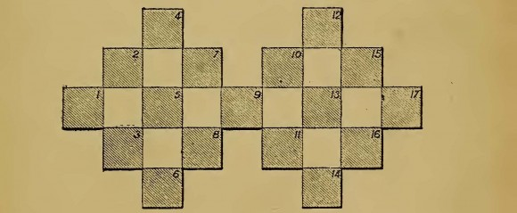

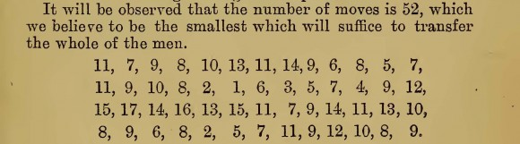

[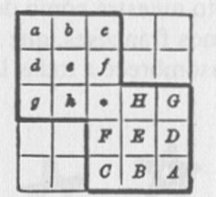](https://culturacientifica.com/app/uploads/2014/01/IMAGEN-13.jpg)The symmetric solution of 46 movements given by Dudeney and collected in the book Mathematical Puzzles of Sam Loyd, edited by Martin Gardner in 1959, is as follows

Hhg • Ffc •CBHh • GDFfehbag • GABHEFfdg • Hhhc • CFf • GHh